Overview

This homework will provide an overview of pulldowns and listboxes. We will be doing the following things:

- Setting up and processing simple listboxes
- The transfer listbox
- Pulldowns (and listboxes) from the database

Exercise 1: Simple Listboxes

Create a new webpage.

Put the following into the webpage:

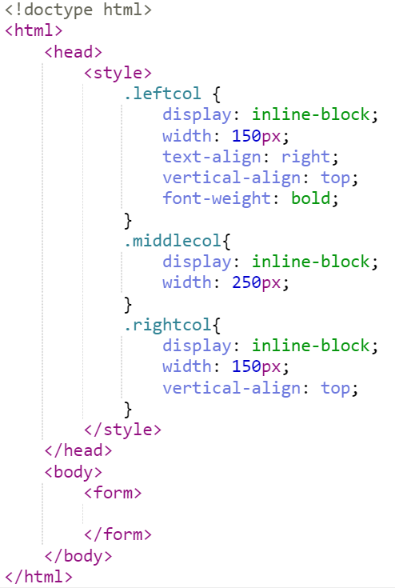
This doesn’t do much.

In HTML, a listbox uses essentially the same commands as a pulldown. To create a listbox, you set the size attribute to a number larger than one. In the form, do the following:

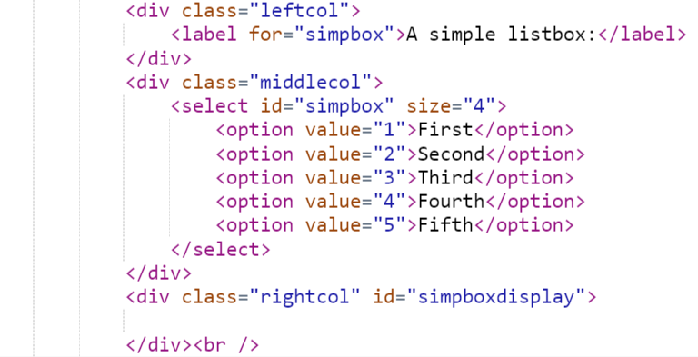
Run it.

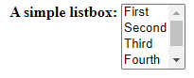

So, other than how it looks, what’s the difference between a listbox and a pulldown? The key difference is one can also normally use a listbox to select multiple things with the keyword multiple.

Write the following HTML code:

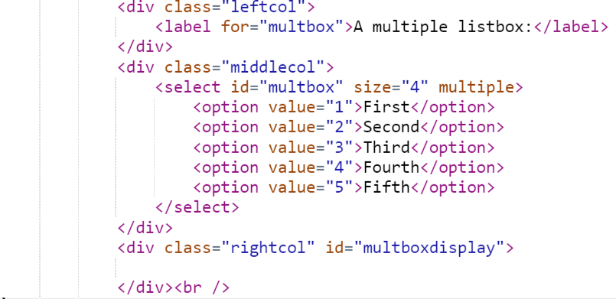
Run the code, and observe that when you click the box with the ctrl or shift key pressed down, you can select multiple options from the listbox.
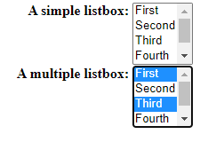
Let’s actually read the listbox values. You do this by looping through the listbox looking for options that have been selected. Create the following JavaScript function.

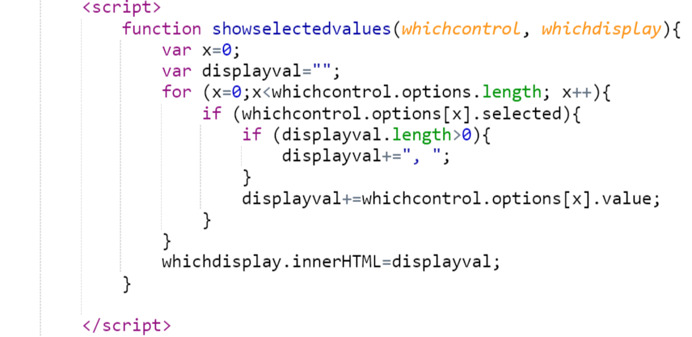
Then, attach it to the onchange events of simpbox and multbox as:

<select id="simpbox" size="4" onchange="showselectedvalues(simpbox,simpboxdisplay);">

And

<select id="multbox" size="4" multiple onchange="showselectedvalues(multbox,multboxdisplay);">

Respectively. Observe how clicking on options changes what is displayed.

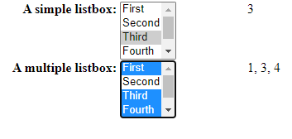

Exercise 2: The Transfer Listbox
Create a new set of listboxes as follows:
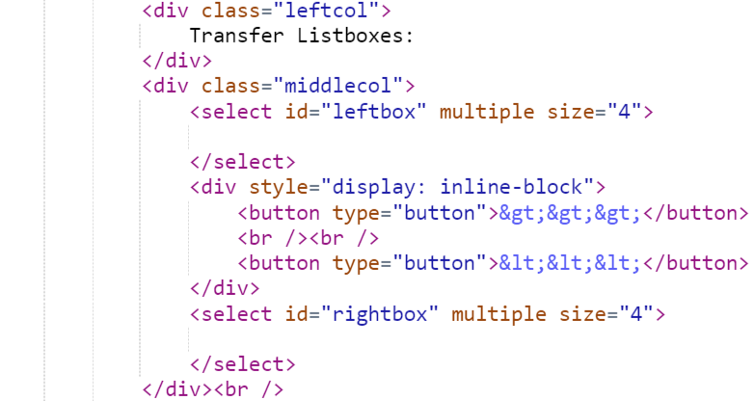

This should produce the following:
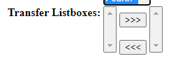
What we are going to do is create a list of options. When the top button is pressed, options are transferred from the left box to the right box. When the bottom button is pressed, options are transferred from the right box to the left box.

To do this, we are going to create a public array of JavaScript objects.

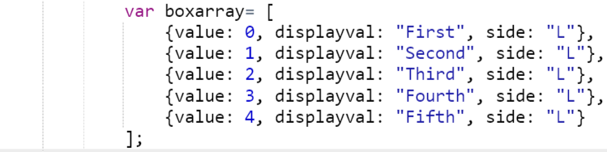
The value is what is going to be stored as value in the listbox options. Displayval is what will be stored in the innerHTML of the option. Finally, side is going to determine whether the option appears on the left or right.

Now, write the following JavaScript function:

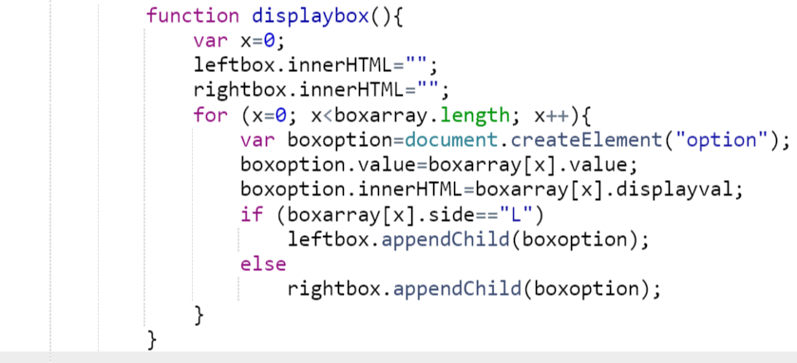
Link this function to the body onload.

<body onload="displaybox();">

Observe how the left listbox is now populated.
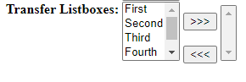
When we click the top button, all selected values in the left listbox need to be shifted to the right. When we click the bottom button, all selected values in the right listbox need to be shifted to the left.

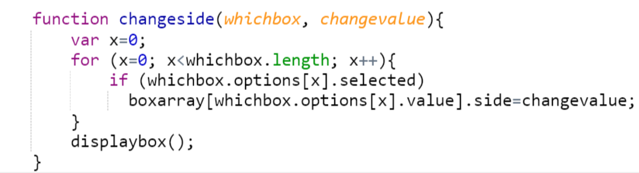
We then need to put the selected function into the buttons.
<div style="display: inline-block">
<button type="button" onclick="changeside(leftbox,'R');">&gt;&gt;&gt;</button>
<br /><br />
<button type="button" onclick="changeside(rightbox,'L');">&lt;&lt;&lt;</button>
</div>

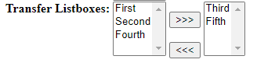

Exercise 3: Database Pulldowns

To do database pulldowns, we first have to link the database to our code. Create a file called bookcat.php with the following code.

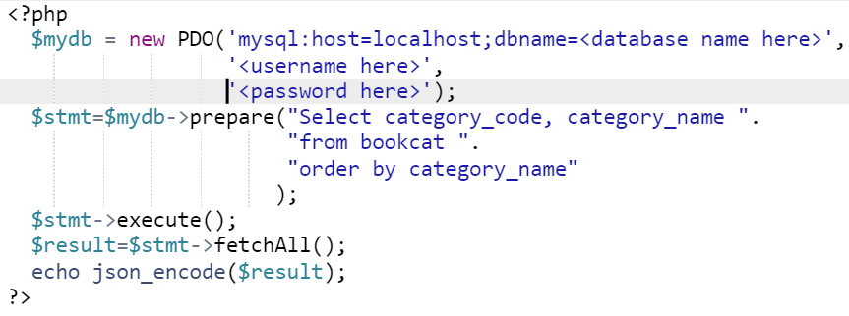
Then in your HTML file, add the following:
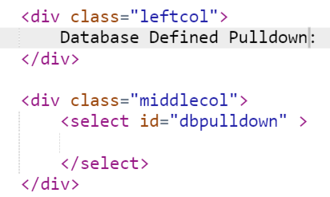
Create the following JavaScript function:
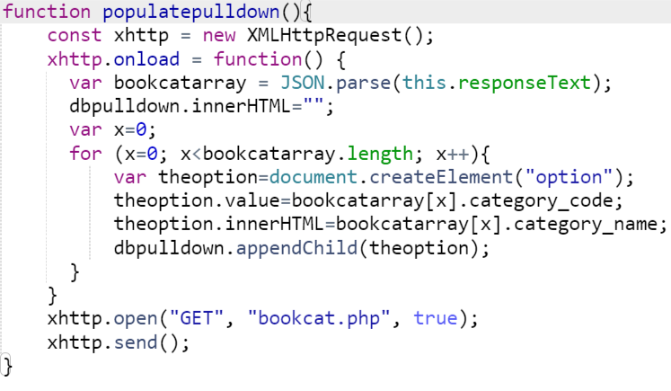
Then link the function to the pulldown in the body onload.

<body onload="displaybox(); populatepulldown();">

If you did everything correctly, this is what you should see:
